Flower Mound Counseling
1190 Parker Square
Flower Mound, TX 7502
(214) 405-4030
info@flomocounseling.com

Flower Mound Counseling, PLLC provides individual, family, and group psychotherapy to clients. All counselors are independent contractors of Flower Mound Counseling. Chris Guzniczak, M.S., LPC, is a Licensed Professional Counselor with Flower Mound Counseling.

Confidentiality: We are committed to confidentiality to the fullest extent allowed by Texas law. You should also know that there are certain situations in which we are required by law to reveal information obtained during therapy to other persons or agencies without your permission. Also, we are not required to inform you of my actions in this regard. These situations include but are not limited to the following: (a) If you threaten bodily harm or death to yourself or another person; (b) If a court of law issues a legitimate court order (signed by a judge), we are required by law to provide the information specifically described in that order; (c) If you reveal information relative to child abuse, child neglect, or elder abuse (past or present), I am required by law to report this to the appropriate authority; (d) If you are in therapy by order of a court of law, the results of the treatment ordered must be revealed of the court; (e) Any sexual improprieties by a former therapist must be reported to the AAMFT Ethics Committee, and (f) If you are seeking payment through an insurance company, we will be required to reveal confidential information to them (each insurer is different). The ethical code of marriage and family therapy prohibits dual relationships between clinician and patient and former patients. This means as our client we cannot meet with you for social occasions or be involved in any business activities with you other than providing psychotherapeutic services.

Risk to Treatment: The goals of therapy are to provide information, emotional support, and skills to improve personal effectiveness, preserve personal safety, and to develop problem solving strategies to deal with current problems. Psychotherapy has both benefits and risks. Psychotherapy has been shown to produce significant improvements in emotional well-being, family and personal relationships, and work and school performance. Risks include experiencing uncomfortable levels of feelings like frustration, sadness, guilt, and loneliness. Although therapy can be a powerful life changing process, there are no guarantees about what will happen. Therapy has a natural process to it, which includes a beginning (getting acquainted, identifying problems, setting goals), a middle (treatment activities-exploring approaches, developing solutions), and an ending (evaluation of goal attainment, after care goals, closure activities). We hope that you will see therapy through all of these phases.

Duty to Warn: In the event that the undersigned therapist reasonably believes that I am a danger, physically or emotionally to myself or another person, I specifically consent for the therapist to warn the person in danger and to contact the following persons, in addition to medical and law enforcement personnel:

Emergency Contact Name Telephone Number

______________________________________________________________________________________

I consent for the undersigned therapist to communicate with me by mail and by phone at the following addresses and phone numbers, and I will IMMEDIATELY advise the therapist in the event of any change:

Address Telephone Number
_____________________________________________________________

Appointments & Missed Appointment Policy:

Appointments: All sessions are scheduled by appointment only. Appointment times are based upon the current fee schedule. If you are filing through a health insurance carrier, please be aware that reimbursement for sessions is based on your policy and you are financially responsible for any charges not covered by the insurance company.

Set Repeated Appointments: Sometimes setting up a set weekly or biweekly appointment time is the best way to ensure that you will be able to get an appointment time or one that best fits your schedule. However, if you make this kind of appointment, you are committed to that time until you specifically state you would like to give it up. If two set appointments are missed, we will only be able to schedule with you on a week-to-week basis to open space for clients that need set appointment times.

Missed Appointments: Appointments canceled with 24 hour notice incur no fees and every effort will be made to reschedule in a timely manner. If you are unable to keep a scheduled appointment, please contact the office at (214) 405-4030 at least 24 hours in advance. Appointments missed or canceled with less than 24 hour notice will be charged a $50 cancellation fee. It cannot be billed to an insurance carrier. I understand that emergencies and health problems do come up and we are willing to consider them when adequate notice is not given. However, No-shows, last minute scheduling conflicts with other professionals, sports events, family events, generally will not be considered. Additionally, if you are billing to a third-party, the individual whose policy is being billed, must be present in order for the session to be billed. Therefore, if that individual does not attend the session, that is considered a missed appointment and you will be responsible for the full fee. Please note that the provider may terminate the counseling relationship after 2 missed appointments without calling to cancel 24 hours prior to your scheduled appointment. Additionally, any balance on the account for missed appointments must be paid prior to rescheduling an appointment.

Legal Proceedings: If you are currently involved or become involved with any legal proceedings, please inform your therapist as soon as possible. It is important that we discuss how the proceedings might impact your work together. If legal actions occur in which you will be responsible to pay your therapist for the following even if the subpoena is sent from the opposing side of the case; (a) the time spent for travel to/from court at the rate of $200.00 per hour per therapist; (b) the time spent on preparing testimony, reports, witness time, and depositions at the rate of $200.00 per hour per therapist; (c)the time spent on mediations and court appearances are billed at $1,500 per half-day and $3,000 per full-day per therapist.

Communication:

Telephone Communication: If we are available we will respond by cell phone after hours and between sessions for non -emergencies for up to 15 minutes w/o charge. That number will also accept confidential voice mail messages. Phone calls over 15 minutes in length will be billed at $2.00 per minute. Please note that telephone calls after 5:00 pm will not be returned until the next business day. If you find yourself facing an emergency situation, please contact emergency services (911) immediately or go to your nearest hospital emergency room.

Text Messaging: This form of communication cannot ensure confidentiality and should only be used for scheduling/cancelling appointments.

Electronic Communication: We cannot ensure confidentiality of any correspondence sent via email and cannot be responsible for breaches in confidentiality resulting from someone getting your password or having access to your account. Therefore, email communication should be reserved merely for scheduling and/or canceling appointments. Additionally, all email correspondence between us will be printed and placed in your file. My direct email address is chrisguz.counseling@gmail.com.

Records and Administrative Services: If you request it, any part of your record in the files can be released to any person or agency you designate. There is a $50 fee to copy a client’s record. Payment in the amount of $200 per hour will be charged for administrative services beyond the scope of the therapy sessions with a minimum of 30 minutes to complete a service. These services include but are not limited to: (a) consultation with other professionals, (b) preparation of reports or correspondence, (c) phone calls lasting over 15 minutes.

Discontinuing Treatment/Complaints: It is also important to understand that you are free to discontinue treatment at any time and agree to notify us immediately so that we may provide you with referrals for continued care. If at any time you wish to file a formal complaint regarding my counseling services, please contact the Texas State Board of Examiners of Professional Counselors and/or Texas State Board of Examiners of Marriage and Family Therapists, Complaints Management and Investigative Section, P.O. Box 141369, Austin, Texas 78714-1369; 1-800-942-5540. Additionally, we have the right to terminate your treatment at any time. Some of the reasons include but are not limited to: boundary violations, non-compliance with treatment, failing to follow appointment policies and procedures, and non-payment of fees and/or services rendered. Should your therapist decide to discontinue treatment, you will be provided a referral source for another psychotherapy professional or agency.

Consent to Treatment:
1.I have received a fee schedule and I agree to pay for services rendered with payment due at the conclusion of each session and no balance will be carried. I understand that if I am seeking reimbursement from a Third- Party Payor, I am financially responsible for all services rendered and agree to pay for claims denied by the third-party payor. I understand that if I am late to a session, the length of that session may be shortened, and I agree to pay for a full session.
2. I understand that I can leave therapy at any time and I have no moral, legal, or financial obligation to complete the maximum number of sessions listed in this contract. However, I understand that money’s paid in advance will not be reimbursed regardless if I choose to terminate treatment.
3. A 24 hour notice is required for cancellation of a scheduled session. Sessions paid in full will not be credited for missed sessions.
4. If I miss an appointment without prior notice and do not contact this office with 10 business days following the missed appointment, then I understand my therapy will have terminated and my file will be closed.
5. I understand that the therapist has the right to see legal recourse to recoup any unpaid balance. In pursuing these measures, the therapist has the right to use confidential information to establish the fee claim.
6. You acknowledge that you have received and understand the Notice of Privacy Practices for this office.

Signed: ______________________________ DOB: ___________ Date: ____________

Signed: ______________________________ DOB:____________ Date: ____________

Therapist: __________________________________ Date: ____________

IF A CLIENT IS A MINOR: I give permission for this minor child(ren) to receive counseling without a parent or guardian present. I have the legal authority to seek and grant permission for professional services for a minor child, there being no legal decree disallowing my authority to assume such responsibility.

Name of Child: _______________________________ DOB: ______________________

Name of Child: _______________________________ DOB: ______________________

Name of Child: _______________________________ DOB: ______________________

Name of Parent or Legal Guardian: __________________________________________

Signed: ____________________________________ Date: ____________________

Therapist: __________________________________ Date: _____________________

2020 Fees and Payment:

Clients or Parents/Guardians are responsible for payment for all services rendered. Payment or Co-Payment is due by the end of each session. Payment may be made with cash, check, or credit card. A completed receipt will be provided at the end of each session documenting the service delivered and fees paid. Please also be aware that there is a $50 fee for any returned/canceled checks and credit card charge backs/declines. Except where we have a contractual agreement with a Third-Party Payor, our fees are as follows:

Individual/Couples Psychotherapy session (50 minutes) $120.00
-includes intake session, parent consult
Individual Intensive session (110 minutes) $220.00
Video/Telephone Psychotherapy session (50 minutes) $120.00
Video/Telephone Psychotherapy session (30 minutes) $80.00
Group Psychotherapy (individual cost) (varies) varies
Cancelation / no-show fee $60.00

________ I give permission to use the following credit card on file to bill me for sessions or for any sessions not cancelled within 24 hours:

CC#: _______________________ EXP: ___/____ CVV: ________ ZIP: ___________

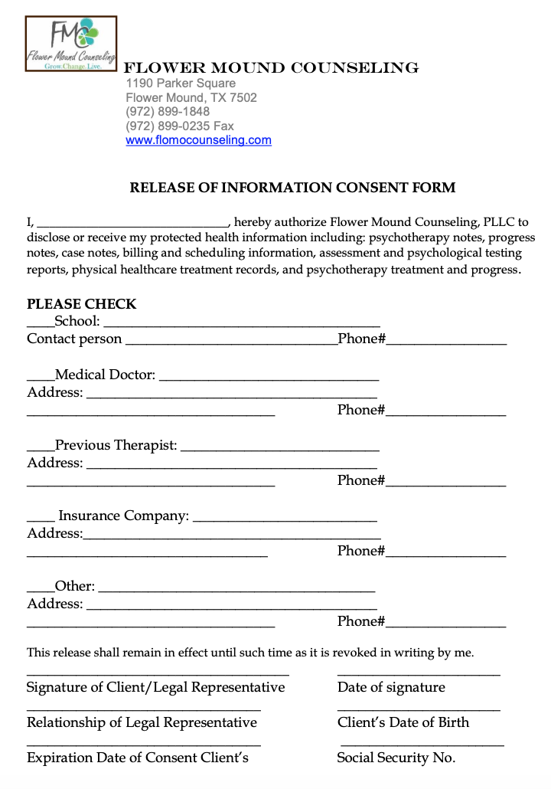

NOTICE OF PRIVACY PRACTICES
Flower Mound Counseling

THIS NOTICE DESCRIBES HOW HEALTHCARE INFORMATION ABOUT YOU MAY BE USED AND DISCLOSED AND HOW YOU CAN GET ACCESS TO THIS INFORMATION. PLEASE REVIEW CAREFULLY.
FMC is required by law to abide by the terms of this Notice Of Privacy Practices, allow you to review this Notice prior to granting consent, and notify you of changes/revisions to this Notice. If you believe your privacy rights have been violated, you may submit a written complaint to FMC or to the Secretary of Health and Human Services describing in detail the manner in which you feel your privacy rights have been violated. Flower Mound Counseling, Inc. will not retaliate against you in any way for filing a complaint with him, or with the Secretary.
YOUR PRIVATE HEALTH INFORMATION (PHI)
Each time you have contact with a healthcare provider for delivery of healthcare, a record of your contact/visit is prepared. This record, maintained in written, oral or electronic format, contains presenting signs/symptoms, results of examination and tests, diagnoses, treatment and future care. Your healthcare record is the physical property of Flower Mound Counseling, but you have certain rights to restrict some of the uses or disclosures of the information contained in your healthcare record. Flower Mound Counseling; however, has the right to use and disclose the information contained in your healthcare record in the process of providing treatment, receiving payment and performing other regular health operations such as:
• Documenting and describing the care you received for legal purposes
• Communicating with other healthcare providers who may be involved in your case
• Educating health care professionals
• Evaluating and improving the care you receive and the outcomes achieved
• Billing and verification of services provided to you
Protecting your privacy and maintaining the security of your health information is one of the most important responsibilities of FMC. Flower Mound Counseling is required by law to maintain privacy and confidentiality of your health information, provide you with this Notice of Privacy Practices, notify you of your rights to restrict use of this information, notify you if FMC. is unable to agree to a requested restriction, and allow you to review the Notice of Privacy Practices prior to granting consent and notifying you of changes/revisions to this Notice. Examples of disclosure of your PHI and your rights concerning PHI are continued below. If you have questions or would like additional information, contact Tiffany Smith the privacy officer for Flower Mound Counseling at 214-405-4030.

EXAMPLES OF DISCLOSURE OF YOUR PHI
Healthcare delivery and treatment: Information obtained from you by FMC is documented in your record and used for the assessment, evaluation, diagnosis and treatment of your health conditions). This information is provided to other healthcare professionals, such as other physicians, specialists, hospital based providers and/or other healthcare providers following your treatment by FMC. This information would only be provided to these individuals by your expressed consent, however.
Billing and Payment: Your PHI is utilized to justify the level of care delivered to you and the charged incurred for the services. This information generally accompanies the bill and is sent to our payers.
Other healthcare operations: FMC. may disclose your PHI to other individuals and businesses in order for him to perform his day-to-day operations. These other individuals and businesses include business associates such as vendors and/or contractors used for billing and claims management. These individuals are held to the same standard of privacy and confidentiality as Flower Mound Counseling.
Reminders and Treatment: FMC may contact you to provide you with information she feels is useful or helpful to you, based on your PHI. For example, she may contact you to schedule an appointment or as an appointment reminder, to suggest alternative treatments, or to provide you with information on treatments you are already receiving.
Other uses and disclosures of PHI not permitted or required by law will be made only with your written authorization. You may revoke your authorization at any time provided that the revocation is in writing, except to the extent that Flower Mound Counseling has already taken action in reliance on your prior authorization. The only exception to this would be under circumstances that are life-threatening or an emergency, such as an individual being acutely suicidal or in some other way in extreme danger. Not all information provided by you to FMC will be recorded in a healthcare record, only that information considered by her to be critical to providing for your care. Other information regarding personal matters in your private life and affairs will not be made part of a healthcare record document.

YOUR RIGHTS CONCERNING PHI - Except as otherwise provided by law, you have a right to:
- receive a paper copy of this Notice of Privacy Practices if you have agreed to receive it electronically;
- receive a confidential communications of PHI if a request is submitted to FMC in writing.
- inspect and copy PHI or records about you in a designated record set as long as the PHI is maintained in the record set;
- ask FMC to amend PHI or records about you in a designated record set as long as the PHI or record is maintained in the record set (FMC is not required to change the information if she deems it to be accurate);
- receive an accounting of disclosures of PHI (a list of the disclosures made by FMC about you for reasons other than treatment, payment or healthcare operations); and
- request that FMC restrict uses or disclosures of your PHI. Though FMC is not required to agree to a restriction, to the extent that it does agree with your request, FMC. may not use or disclose the protected PHI in violation of the restriction unless the information is needed to provide emergency treatment, or is otherwise permitted or required by law.

Effective Date: 01/15

